

**TAYYABA REHMAN**

**49690**

**LAB 8**

**LAB TASK 1:**

**ERD:**

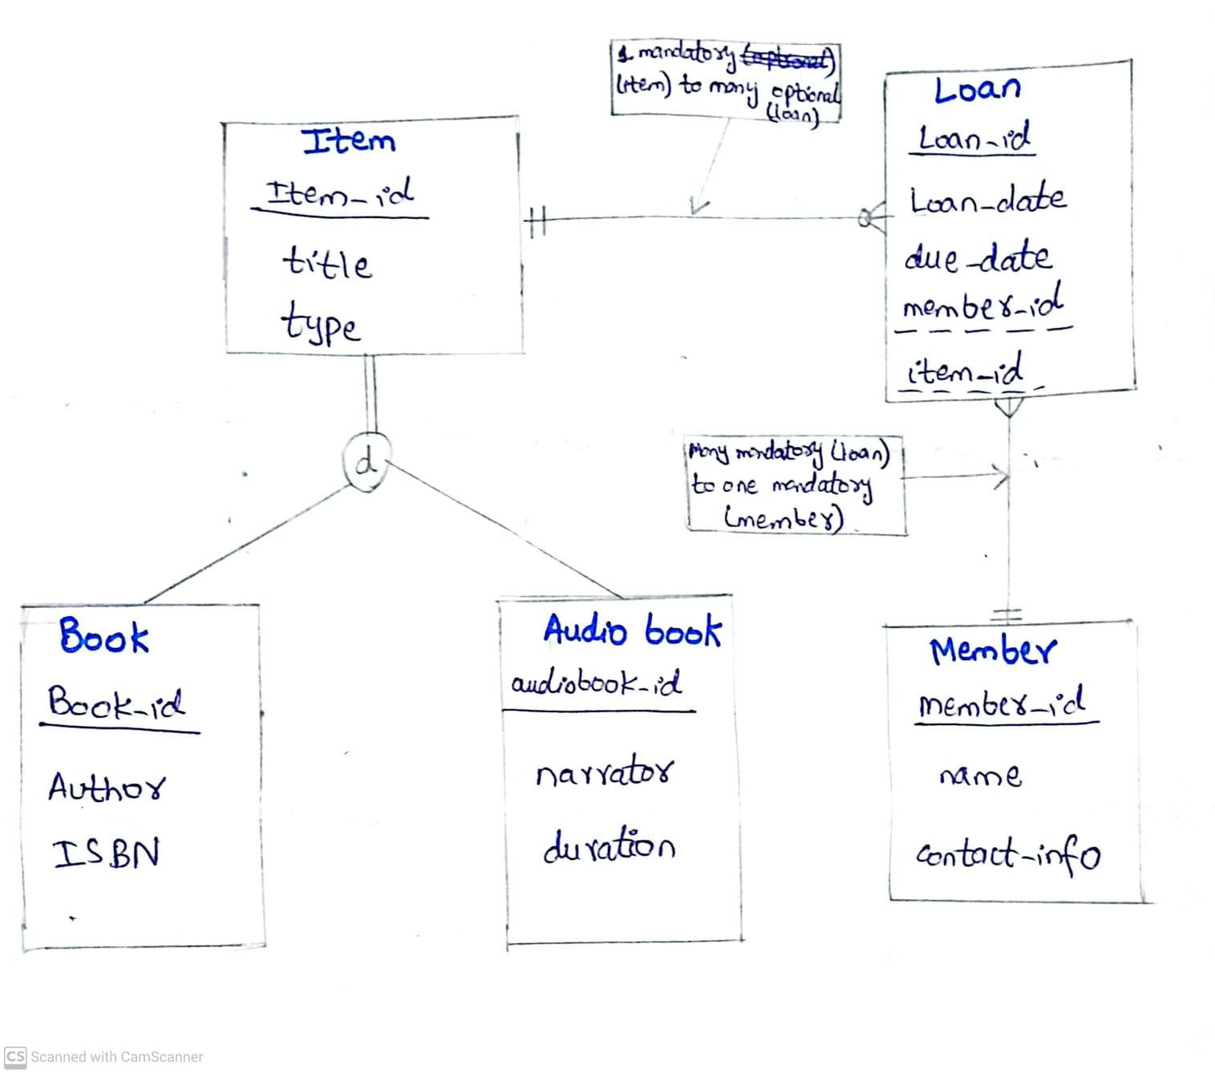

**LAB TASK 2:**

**CODE:**

CREATE database LAB8;

USE LAB8;

CREATE TABLE Item (

item_id INT

PRIMARY KEY,

title VARCHAR(255) NOT NULL,

type VARCHAR(50) NOT NULL CHECK (type IN ('Book', 'Audiobook'))

);

CREATE TABLE Book (

book_id INT PRIMARY KEY,

author VARCHAR(255) NOT NULL,

ISBN VARCHAR(20),

item_id INT,

FOREIGN KEY (item_id) REFERENCES Item(item_id),

CONSTRAINT chk_book_type CHECK (item_id IN (SELECT item_id FROM Item WHERE type = 'Book'))

);

CREATE TABLE Audiobook (

audiobook_id INT PRIMARY KEY,

narrator VARCHAR(255) NOT NULL,

duration INT NOT NULL, -- Duration in minutes

item_id INT,

FOREIGN KEY (item_id) REFERENCES Item(item_id),

CONSTRAINT chk_audiobook_type CHECK (item_id IN (SELECT item_id FROM Item WHERE type = 'Audiobook')) -- Disjoint constraint

);

CREATE TABLE Member (

member_id INT PRIMARY KEY,

name VARCHAR(255) NOT NULL,

contact_info VARCHAR(255)

);

CREATE TABLE Loan (

loan_id INT PRIMARY KEY,

loan_date DATE NOT NULL,

due_date DATE NOT NULL,

member_id INT,

item_id INT,

FOREIGN KEY (member_id) REFERENCES Member(member_id),

FOREIGN KEY (item_id) REFERENCES Item(item_id)

);